# Chapter 2 - Women Entrepreneurship

**Question and Answers**

**All Lectures Uploaded on YouTube:** [**https://tinyurl.com/fkm9-english**](https://tinyurl.com/fkm9-english)

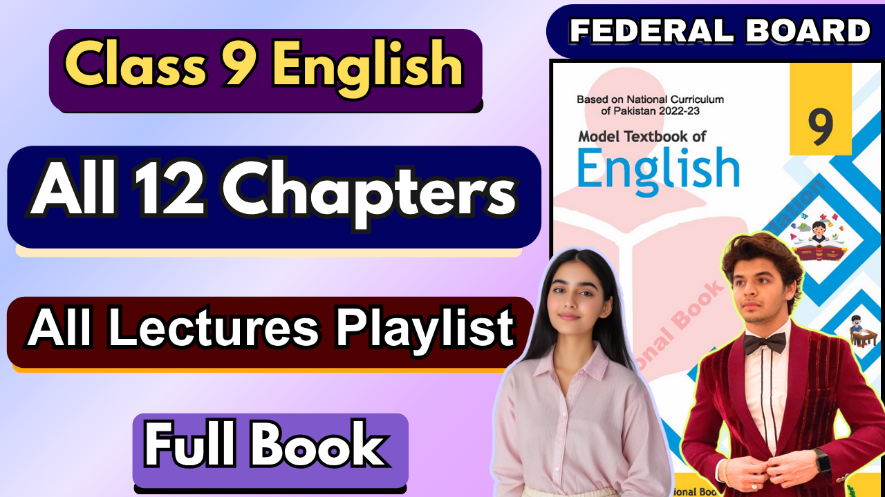

### Q1: Who is Hazrat Khadija (RA), and what role did she play in business during her time? **Answer**: Hazrat Khadija (RA) was a successful businesswoman during the time of the Prophet Muhammad (PBUH). She was known for her intelligence, business acumen, and leadership in running one of the most important caravan trades. She was respected, and knowledgeable, and played a key role in women's financial independence and self-sustenance, showing that success in business was possible even during her time.

### Q2: What motivates the author, Zaynab Abdi, to consider starting her own business? **Answer**: Zaynab Abdi was motivated to start her own business by seeing Somali women from her homeland in Yemen, as well as Muslim women in the U.S., start their businesses and succeed. Her drive comes from a desire to emulate their success and contribute to the growing community of female entrepreneurs, while also overcoming cultural challenges.



### Q3: According to Anisa, what is important for entrepreneurs to remember when starting a business?

### **Answer**: Anisa emphasizes that entrepreneurs need to remember their motivation and ultimate goals. She talks about the importance of perseverance and passion, even in the face of challenges or initial small-scale failures. Anisa believes that keeping in mind the reasons for starting a business, such as independence, community involvement, and passion, is key to long-term success.

### Q4: What is Zaynab Abdi's personal entrepreneurial goal, and how does it reflect her passion?

### **Answer**: Zaynab Abdi’s personal entrepreneurial goal is to start her own food truck to cook Yemeni food and share her cultural heritage with others. This reflects her passion for cooking and connecting with people through food, while also contributing to her community.

### Q5: How does the author encourage Muslim women to approach entrepreneurship in the text?

### **Answer**: The author encourages Muslim women to pursue their passions and talents and to take inspiration from successful examples of other women, like Anisa Haji and Annie Qaiser, who have started their businesses in the beauty and wellness industries. Zaynab emphasizes that even starting small can have a big impact, and Muslim women should be unafraid of the challenges they may face.

### Q6: Why does the author believe it’s essential for Muslim women to start their own businesses, even if they start small or face failures?

### **Answer**: The author believes that starting a business, even small, helps Muslim women gain financial independence, empower themselves, and inspire future generations. Despite potential failures or stereotypes, their entrepreneurial efforts contribute to breaking barriers and encouraging other Muslim women to follow their dreams.

### Q7: How do the stories of Anisa Haji and Annie Qaiser challenge stereotypes or cultural norms about beauty and wellness?

### **Answer**: Anisa Haji and Annie Qaiser challenge stereotypes by creating businesses that emphasize natural beauty and celebrate diversity. Anisa's skincare products target dark-skinned women, addressing the misconception that beauty is limited to certain skin tones. Annie’s wellness products reflect South Asian heritage, embracing cultural traditions in the beauty industry.

### Q8: What are some key takeaways from the text that you find inspiring or insightful for aspiring entrepreneurs, especially Muslim women?

### **Answer**: Key takeaways include the importance of pursuing one's passion, overcoming societal barriers, and recognizing the value of starting small. The text highlights the significance of financial independence, cultural pride, and resilience for Muslim women in entrepreneurship. It also shows that every step toward achieving these goals helps to inspire others in the community.

### Q9: Can you identify any additional questions or areas of interest that arose for you as you read the text?

### **Answer**: One area of interest might be exploring further how entrepreneurship among Muslim women can evolve globally and how different cultural contexts affect their experiences. Additionally, the role of education and mentorship in empowering Muslim women entrepreneurs could be worth discussing.

### Grammar

### Hyphens

* Are punctuation marks resembling a small horizontal line **(-)**
* They are used to form compound words.
* Connect two or more words or parts of words to show that they form one unit of sense.

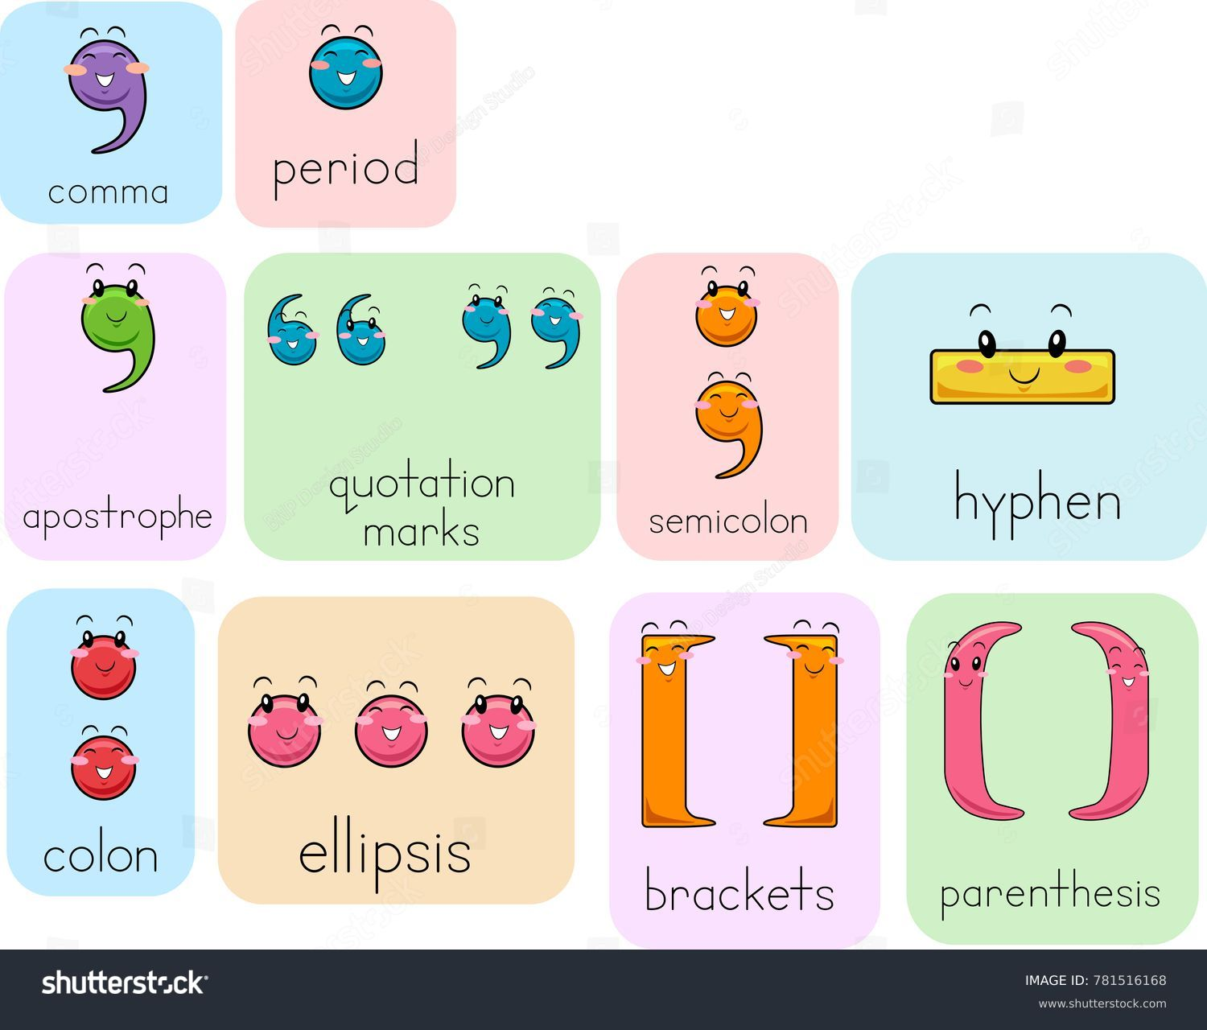

### Exercise 1

1. She is a **well-known** author.
2. The **two-year-old** toddler is very energetic.
3. His computer skills are **top-notch.**
4. I bought a **brand-new c**ar yesterday.
5. The restaurant offers **gluten-free** options.

### Exercise 2: Hyphenated Nouns and Adjectives

#### Q: Fill in the blanks with the correct hyphenated nouns or adjectives:

Adjectives: An adjective is a word that describes or defines a noun

1. The **well-decorated house** was decorated for the holiday season.
2. My **well-being** is full of childhood memories.
3. We attended a **well-known** conference on technology.
4. She's a **best-selling** writer known for her suspense novels.
5. The school organized a **fund-raising** event for charity.

### Exercise 3: Words Ending in "ough"

**Q: Complete each sentence with the correct word ending in "ough" from the given options:**

1. The weather outside is very rough today.
2. I can't believe you ate the whole pizza! You have a big enough appetite.
3. The boat sailed smoothly through the rough water.
4. We'll need to work through this problem together.
5. He's trying to toughen the math equation.

## Exercise 4: Creating Hyphenated Phrases

* 1. High-mountain
  2. High-school
  3. High-jump
  4. High-tide
  5. High-five

## Exercise 5: Hyphen Use in Compound Adjectives

1. She is a **twenty-year-old** woman
2. They live in a **small-sized house**
3. The project is a **time-consuming** research
4. He has a part-time job and a **full-time** commitment
5. The story was set in the **late-evening** hours

## Denotative and Connotative Meanings

**Denotation:** The literal meaning of a word, as found in a dictionary.

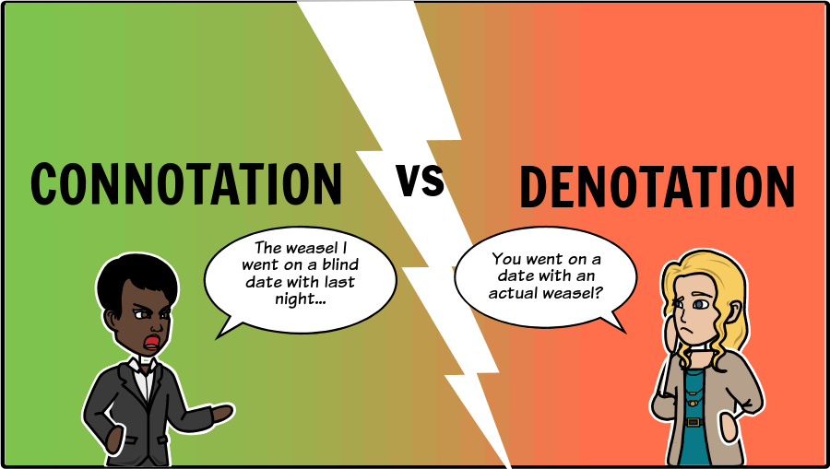

**Connotation:** The emotional or idea associations associated with a word beyond its literal meaning.

## Exercise 6: Identifying Connotative and Denotative Meanings

#### Connotative:

* + snake (negative connotations like danger, slithering)
  + mansion (positive connotations like luxury, and grandeur)
  + skinny (negative connotations like underweight, unhealthy)

#### Denotative:

* + home
  + slim
  + house
  + cottage
  + childish
  + childlike
  + houseful

## Exercise 7: Connotative vs. Denotative Sentence Creation

#### Denotative:

1. The fire burned the house down.
2. The student studied hard for the exam.
3. The rich man donated a million dollars to charity.
4. The patriot fought for his country.
5. The queen ruled the kingdom.

#### Connotative:

1. The fire of passion ignited their love.
2. The student was a bookworm, always buried in her studies.
3. The rich man was a miser, hoarding his wealth.
4. The patriot was a traitor, betraying his country.
5. The queen was a tyrant, ruling with an iron fist.

### Exercise 8: Choosing Words for Tone

1. **Informal Social Media Post about a Recent Achievement**

This tone should be casual, friendly, and enthusiastic.

#### Example:

“Guess what? I just landed my dream job! Can’t believe it finally happened. Thanks for all the love and support, you guys! ”

* + **Tone:** Informal, celebratory, and personal.



1. **Negative Critique of a Restaurant Experience**

This tone should express dissatisfaction and frustration.

#### Example:

“I went to [Restaurant Name] last night, and it was a huge disappointment. The

service was painfully slow, and the food was bland and overpriced. Definitely not worth the hype.”

* + **Tone:** Negative, critical, and direct.

1. **Neutral Email to a Colleague about a Work-Related Matter**

This tone should be professional and objective, focusing on facts rather than emotion.

#### Example:

“Hi [Colleague’s Name],

I just wanted to follow up on the report you submitted last week. Could you clarify a few points before we proceed with the next steps? Let me know when you’re available to discuss this.

Best regards, [Your Name]”

* + **Tone:** Neutral, polite, and straightforward.

### Exercise 9: Exploring Similar Denotations

### Choose two words with similar denotations but different connotations, and analyze how they impact tone.

1. **Sentences:**
   * Word 1: *Thin* (neutral or positive connotation)
     + “She has such a thin figure that everyone admires.”
   * Word 2: *Skinny* (negative connotation)
     + “She looks so skinny that it’s almost unhealthy.”
2. **Impact on Tone:**
   * **Thin:** This word carries a more neutral or even positive connotation, suggesting a graceful or healthy body. The sentence sounds complimentary and positive.
   * **Skinny:** This word often has a negative or critical connotation, implying an unhealthy or unattractive appearance. The sentence, therefore, comes across as judgmental or concerned.

### Exercise 10: Exploring Dissimilar Denotations

1. **Chosen Words:**
   * Word 1: *Glow* (denotation: to emit soft light)
   * Word 2: *Shine* (denotation: to reflect light brightly)
2. **Sentences:**
   * *Glow:*

“Her confidence made her glow, and it was impossible not to notice her presence in the room.”

* + *Shine:*

“He always shines during presentations, impressing everyone with his charisma and knowledge.”

3. **Explanation:**

Though *glow* and *shine* have different denotations (emitting vs. reflecting light), their

**connotations** both suggest something radiant, positive, and attention-grabbing in these contexts.

* + In the first sentence, *glow* implies an inner light, suggesting quiet confidence and warmth.
  + In the second, *shine* implies a more external or visible success, suggesting someone stands out due to their abilities.

**Literary Devices**

**Literary devices** are techniques that writers use to express ideas, enhance their writing, and convey meaning in a more impactful way. They help to evoke emotions, add depth, and engage the reader. These tools can shape how the reader experiences and

interprets the text, creating a more vivid or layered understanding.



**Euphemism**: A mild or indirect word or phrase used to replace a more direct, harsh, or unpleasant one.

* + *Example*: "Passed away" instead of "died."

**Oxymoron**: A figure of speech where two opposite or contradictory words are combined.

* + *Example*: "Bittersweet" or "deafening silence."

### Literary Devices:

* + **Definition**: Techniques that writers use to create a specific effect, convey meaning, enhance the narrative, or engage readers on a deeper level.
  + **Scope**: Literary devices encompass a wide range of elements used in storytelling,

including narrative techniques, structural tools, and language styles.

* + **Purpose**: They help develop themes, characters, plots, and the overall message of a work.
  + **Examples**: Metaphor, symbolism, foreshadowing, irony, allegory, allusion, flashback, and tone.
  + **Usage**: Literary devices are more comprehensive and can influence the overall structure or deeper layers of meaning in a text.

#### Example:

* + - **Foreshadowing** in a novel may give hints about future events in the story, adding suspense.
    - **Irony** in a story can reveal a character’s misunderstanding, providing humor or insight.

### Figures of Speech:

* + **Definition**: Specific linguistic expressions that deviate from literal meaning to create an effect, often focusing on imagery, comparison, or emphasis.
  + **Scope**: Figures of speech are a subset of literary devices, focusing mainly on

language and the use of words in non-literal ways to make writing more vivid or expressive.

* + **Purpose**: They are used to make descriptions more imaginative, creative, or powerful by playing with the meanings and sounds of words.
  + **Examples**: Simile, metaphor, personification, hyperbole, oxymoron, onomatopoeia, and alliteration.
  + **Usage**: Figures of speech are more focused on individual phrases or sentences and how language is manipulated to make an impact.

#### Example:

* + - **Simile**: "Her voice was like velvet" (a comparison using "like").
    - **Personification**: "The wind whispered through the trees" (giving human qualities to non-human things).

**Glossary**

1. **Entrepreneurship**
   1. Maria started her own online boutique as a budding entrepreneur.
      1. **A budding entrepreneur** is someone who is in the early stages of their entrepreneurial journey. They are typically new to starting and running their own business, but they have the potential to become successful entrepreneurs in the future.

The term "budding" suggests that they are still growing and developing their skills and knowledge as business owners.

* 1. John's entrepreneurial spirit led him to launch a successful tech startup.

1. **Businesswoman**
   1. Maria is a successful businesswoman who owns her own fashion company.
2. **Caravan**
   1. A **caravan** is a group of travelers, typically merchants or traders, who journey together across long distances, often through deserts or remote areas, usually for safety. Historically, it referred to groups transporting goods using animals like camels.
   2. a vehicle equipped for living in, typically [towed](https://www.google.com/search?sca_esv=f2ad83ee939cc1c8&sca_upv=1&rlz=1C1GCEJ_enPK1092PK1096&sxsrf=ADLYWIK6Sw3Jp-2IukpJFB95J7JKq1kM5A%3A1727808605785&q=towed&si=ACC90nwXlEU2j3qee_ajN1FbIPWBV44bgpDhcHgC9r1dD14OJyFowf1cxE34K78p6L6HMKPii9jN95tPaMXgov8_yL1HQpiMTA%3D%3D&expnd=1&sa=X&sqi=2&ved=2ahUKEwj69b_R7O2IAxXNgf0HHSgtNLoQyecJegQIJRAP) by a car and used for holidays.
      1. The caravan of merchants traveled across the desert, carrying precious goods.
3. **Financial Independence**
   1. Financial independence gives you the freedom to make choices without being constrained by money.
4. **Acumen**
   1. Financial acumen is the ability to understand and manage financial matters effectively.
5. **Ambitions**
   1. His ambitions include traveling the world and starting his own business.
6. **Empowerment**
   1. Through education and economic opportunities, we can empower marginalized communities.
7. **Skincare Products**
   1. Natural skincare products are becoming increasingly popular due to their potential benefits for sensitive skin.
8. **Heritage:**
   1. culture, language, and traditions (foods, etc)
   2. **Heritage** refers to the traditions, customs, beliefs, cultural practices, and historical legacy passed down through generations within a community or society.
      1. Preserving our cultural heritage is important for future generations.
      2. The historical buildings in the city center are a valuable part of our heritage.
9. **Sustainability:** The company's sustainability initiatives included reducing waste and using renewable energy.
10. **Narrative:** The author's narrative style was engaging and informative.

